A mini project report submitted on

**“** **LUDO ”**

For partial fulfilment of the requirement of the degree of

Bachelor of Technology

In Computer Science & Engineering

By

|  |  |
| --- | --- |
| **STUDENT NAME** | **PRN NO.** |
| Mr. Nikam Kiran Gungaji | 2021076081 |
| Mr. Patil Aditya Vijay | 2021075926 |
| Mr. Patnekar Vivek Sandeep | 2021076002 |
| Mr. Patil Akhilesh Ajit | 2021076008 |
| Mr. Kumbhar Prathamesh Ramdas | 2021075918 |

Under the guidance of

Prof. P.G. Sanmane

**Academic Year 2022-23**



**Department of Computer Science & Engineering**

**Sant Gajanan Maharaj College of Engineering , Mahagaon**





**NAAC B++ Accredited & ISO 9001:2015 Certified Institute**

**SANT GAJANAN MAHARAJ COLLEGE OF ENGINEERING,**

**MAHAGAON**

**Site- Chinchewadi, Tal – Gadhinglaj, Dist – Kolhapur 416502**



**CERTIFICATE**

This is to certify that, following students have satisfactorily completed the mini project work entitled, “ **LUDO ”.** This mini project is being submitted for the partial fulfillment of the award of degree of **Bachelor of Technology** in **Computer Science and Engineering** under Shivaji University, Kolhapur, for year 2022-2023.

.

|  |  |  |
| --- | --- | --- |
| **STUDENT NAME** | **PRN NO.** | **SIGNATURE** |
| Mr. Nikam Kiran Gungaji | 2021076081 |  |
| Mr. Patil Aditya Vijay | 2021075926 |  |
| Mr. Patnekar Vivek Sandeep | 2021076002 |  |
| Mr. Patil Akhilesh Ajit | 2021076008 |  |
| Mr. Kumbhar Prathamesh Ramdas | 2021075918 |  |

**Prof. P. G. Sanmane Mr. S. G. Swami**

**Guide Head of Department**

**Examiner Dr. S. H. Sawant**

**Principal**

# ACKNOWLEDGEMENT

We would like to express our sincerely gratitude towards respected Hon. Founder Chairman Adv. Annasaheb D. Chavan, trustee & all Board of Directors, our beloved Principal Dr. S. H. Sawant for his encouragement & support.

We are very thankful to. Prof. S. G. Swami (Head of Computer Science & Engg. dept) & respected guide Prof. P. G. Sanmane for her constant encouragement and valuable guidance during the completion of this project & valuable co-operation & guidance during this project work & we also thank our mini project coordinator Prof. P. G. Sanmane.

We take this opportunity to thank the entire Teaching & Non-Teaching members of CSE dept. for their co-operation and their helpfulness during this project work. Last but not the least assistance offered by various friends and colleagues related directly or indirectly to this work are also gratefully acknowledged.

|  |  |
| --- | --- |
| **STUDENT NAME** | **PRN NO.** |
| Mr. Nikam Kiran Gungaji | 2021076081 |
| Mr. Patil Aditya Vijay | 2021075926 |
| Mr. Patnekar Vivek Sandeep | 2021076002 |
| Mr. Patil Akhilesh Ajit | 2021076008 |
| Mr. Kumbhar Prathamesh Ramdas | 2021075918 |

# ABSTRACT

This is a simple GUI based strategy board game which is very easy to understand and use. All the playing rules are the same just like we play in real time ludo. This is a simple 2D multi player game. After starting the game, a GUI ludo board appears, other rules are the same. First, the player has to roll the dice. The main thing in this simple GUI based game is that the player just has to press “ 1 ” to roll the dice. At the top of the board, it displays a dice with the number. The player has to keep on rolling until there’s a possible pawn to move. All the game movements are to be performed manually by the player. A simple 2D GUI is provided for easy game play. The game play design is so simple that user won’t find it difficult to use and understand.

## INDEX

## Sr No Name Page No

1. Problem Statement 7
2. Introduction 8
3. Software and hardware requirements 9
4. Flowchart 10
5. Block diagram 12
6. Working / Implementation 14
7. Input-output scenario 15
8. Conclusion 21
9. Future work 22
10. Reference: 23
11. Web Reference
12. Book Reference

**PROBLEM STATEMENT**

The problem at hand is to design and implement a digital version of the ludo game that meets the following requirement :

1. Game board
2. Game logic
3. User interface
4. Game progression

## INTRODUCTION

In this project, the basic ludo that is present in the real world is computerized i.e., the program that is written in this project creates a board which is quite similar to that of the board that is seen everywhere. Special areas of the ludo board are typically coloured yellow, green, blue, red. Each player is given a color and possesses four tokens(coins) of one color in their game. The board is normally square with a cross-shaped game track, with each arm of the cross consisting of three columns with six squares per each column. The middle column consists of five colored squares which represent the player’s respective home column. A sixth colored square which is not on the home column represents the player’s starting square. At the centre of the board is a large finishing square often composed of triangles in the four colors atop the player’s home column thus forming the arrows pointing to the finish.

## SOFTWARE AND HARDWARE REQIREMENT

**SOFTWARE REQUIREMENTS**

Language used : C Language  
 Software : dev c++ with including graphics( graphics.h ).  
 Operating system : windows 10

**HARDWARE REQUIREMENTS**

System : AMD  
Hard disk : Not necessary.  
RAM : 2GB(min)  
Processor : i5  
Memory : 128 GB SSD(min)

## FLOWCHART

Start Reference

Book Reference

Choose player

Choose colour

Roll dice

Stop

If got killed

Kill othter coin

If r!=6

if r=6

Wait until 6

Move coin

Finish the game

## BLOCK DIAGRAM

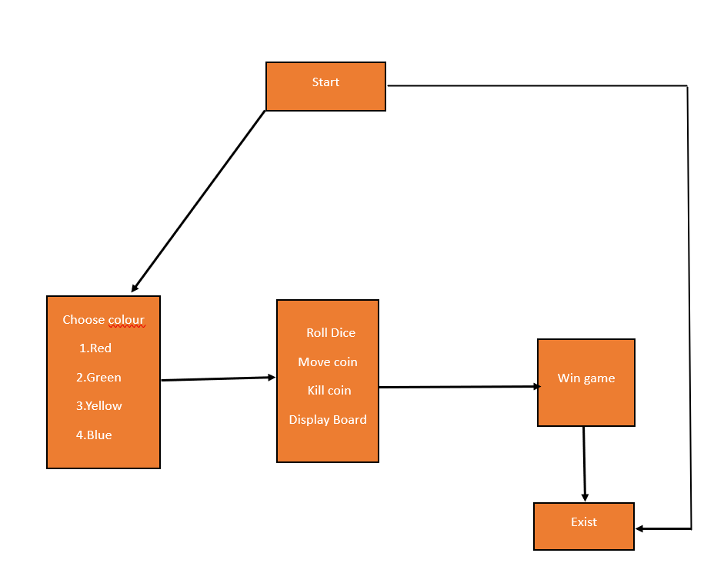

## IMPLEMENTATION

* The Ludo Game Mini Project is a digital implementation of the popular board game called Ludo. It recreates the gameplay mechanics and rules of the traditional Ludo game in a user-friendly graphical interface.
* During the implementation part of the Ludo game we have mainly focused on retrieval of the information as easy as possible, and without ambiguities.
* we have use some loops like for loop, while loop and switch case in our project.
* We use file handling to store the rules of the ludo game.
* We Have use graphics in our program to show the ludo board.
* Some logic and functions that we used to implement in our project.

Void rd()

Void display_Board()

* The implementation includes the following key steps:

1. Game Initialization: Initialize the game board, player tokens, and starting positions.

2. User Interaction: Enable user actions such as dice rolling, token selection, and gameplay actions through the GUI.

3. Dice Rolling: Generate a random number between 1 and 6 to simulate the outcome of the dice roll.

4. Token Movements: Track token positions and update them based on the dice roll, ensuring adherence to movement rules and game board boundaries.

5. Game Rules: Enforce game rules such as allowing a player to roll again on a six, capturing opponents' tokens, and determining win conditions.

6. Game Progress and Display: Update and display relevant information, including the current player's turn, token positions, and messages.

7. Testing and Debugging: Conduct rigorous testing and debugging to ensure the accuracy and stability of the implementation.

## INPUT-OUTPUT SCENARIO

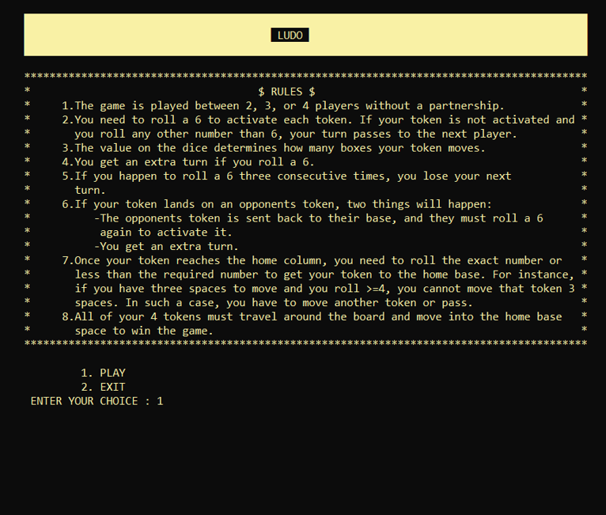

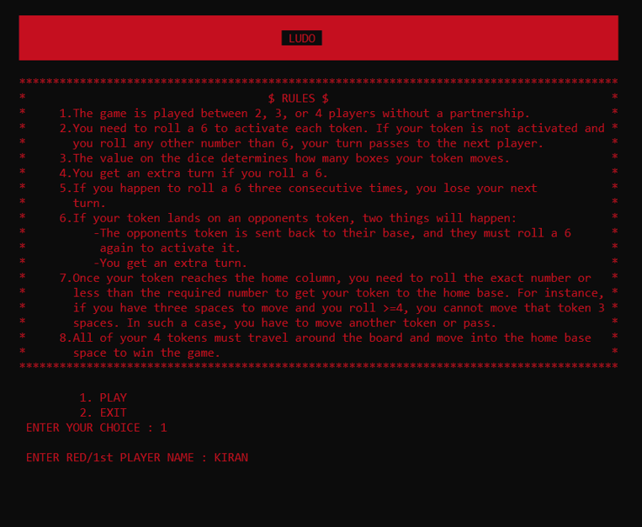

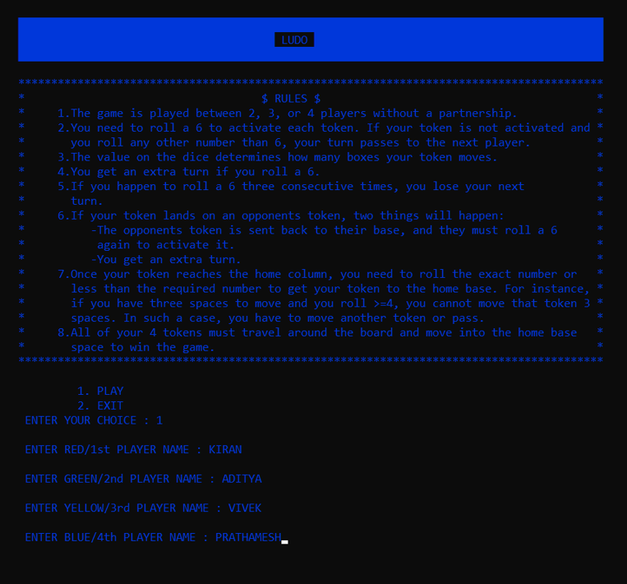

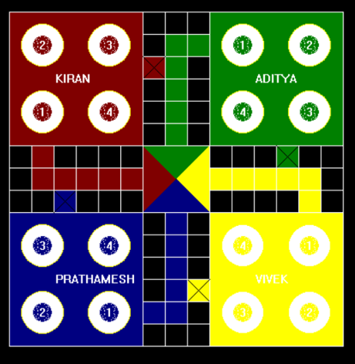

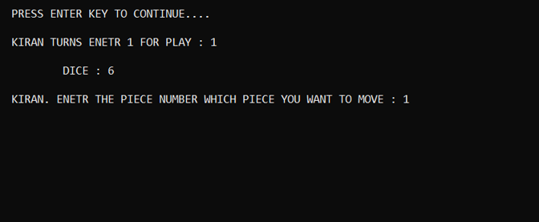 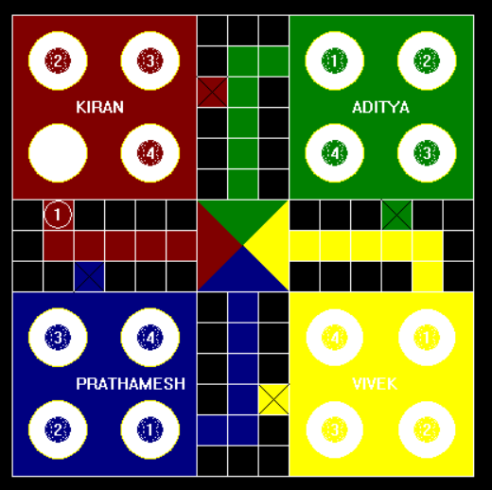

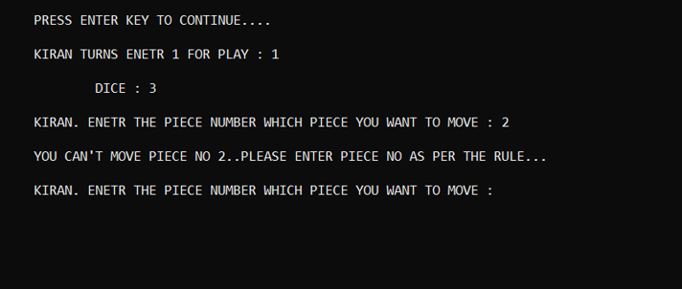

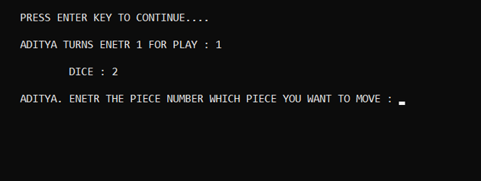 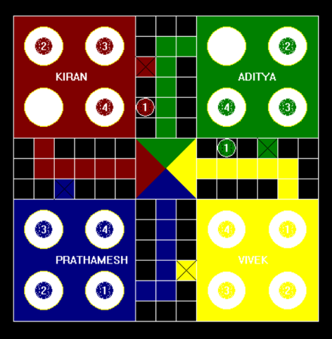

**CONCLUSION**

This project is one of the basic GUI applications of the C Programming. This game can be played and enjoyed by all the people who are very much interested. All the players whoever they are, will become much attracted to the game as long as they are playing it. There will be no trouble playing the “ LUDO ”.

**FUTURE SCOPE**

As the technology changes or new requirements are expected by the user, to enhance the functionality of the product may require new versions to be introduced. Here the player must roll the dice for all the colours which is very time taking. The enhancement is going to be that the player will have a chance to select their required colours to play the game. Also a few changes can be done to the appearance of the board and we can upgrade for multiplayer game.

**REFERENCE**

**WEB REFERENCE**

1. <https://youtube.com/playlist?list=PLiOa6ike4WAFOn9oStv0YI9QMcCVzv-AV>
2. <https://www.udemy.com/course/c-programming-for-beginners-programming-in-c/>

**BOOK REFERENCE**

1. C the Complete Reference by Herbert Schild (Tata McGraw Hill) 4th Edition.

2. The C Programming Language- Brian W. Kernighan, Dennis Ritchie 2nd Edition.